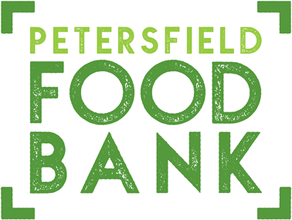

Petersfield Food Bank provides bags of food to families and individuals in difficulties who are referred by various statutory and voluntary agencies working in the Petersfield area.
We are currently low on the following items:

Tinned soup
Tinned tomatoes
Tinned fruit
Tinned rice pudding
Tins or cartons of custard
Jam (not homemade)
Packet soup
Rice (long grain, basmati etc)
Granulated sugar (small pack)
Porridge oats
Coffee
Drinking chocolate

NO FRESH OR FROZEN/CHILLED FOOD

For further details regarding Petersfield Food Bank
visit: https://pactfoodbank.org.uk/

Registered Charity CIO No. 1193002

